**EXPERIMENT -6**

Draw the DFD to be considered while codding the individual processes or functions

Context Diagram

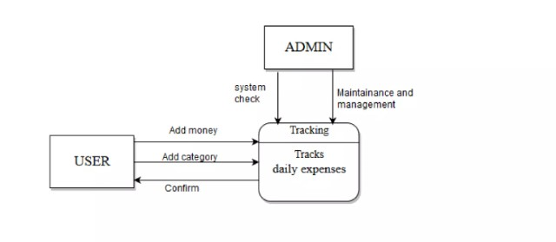

DFD level 1

